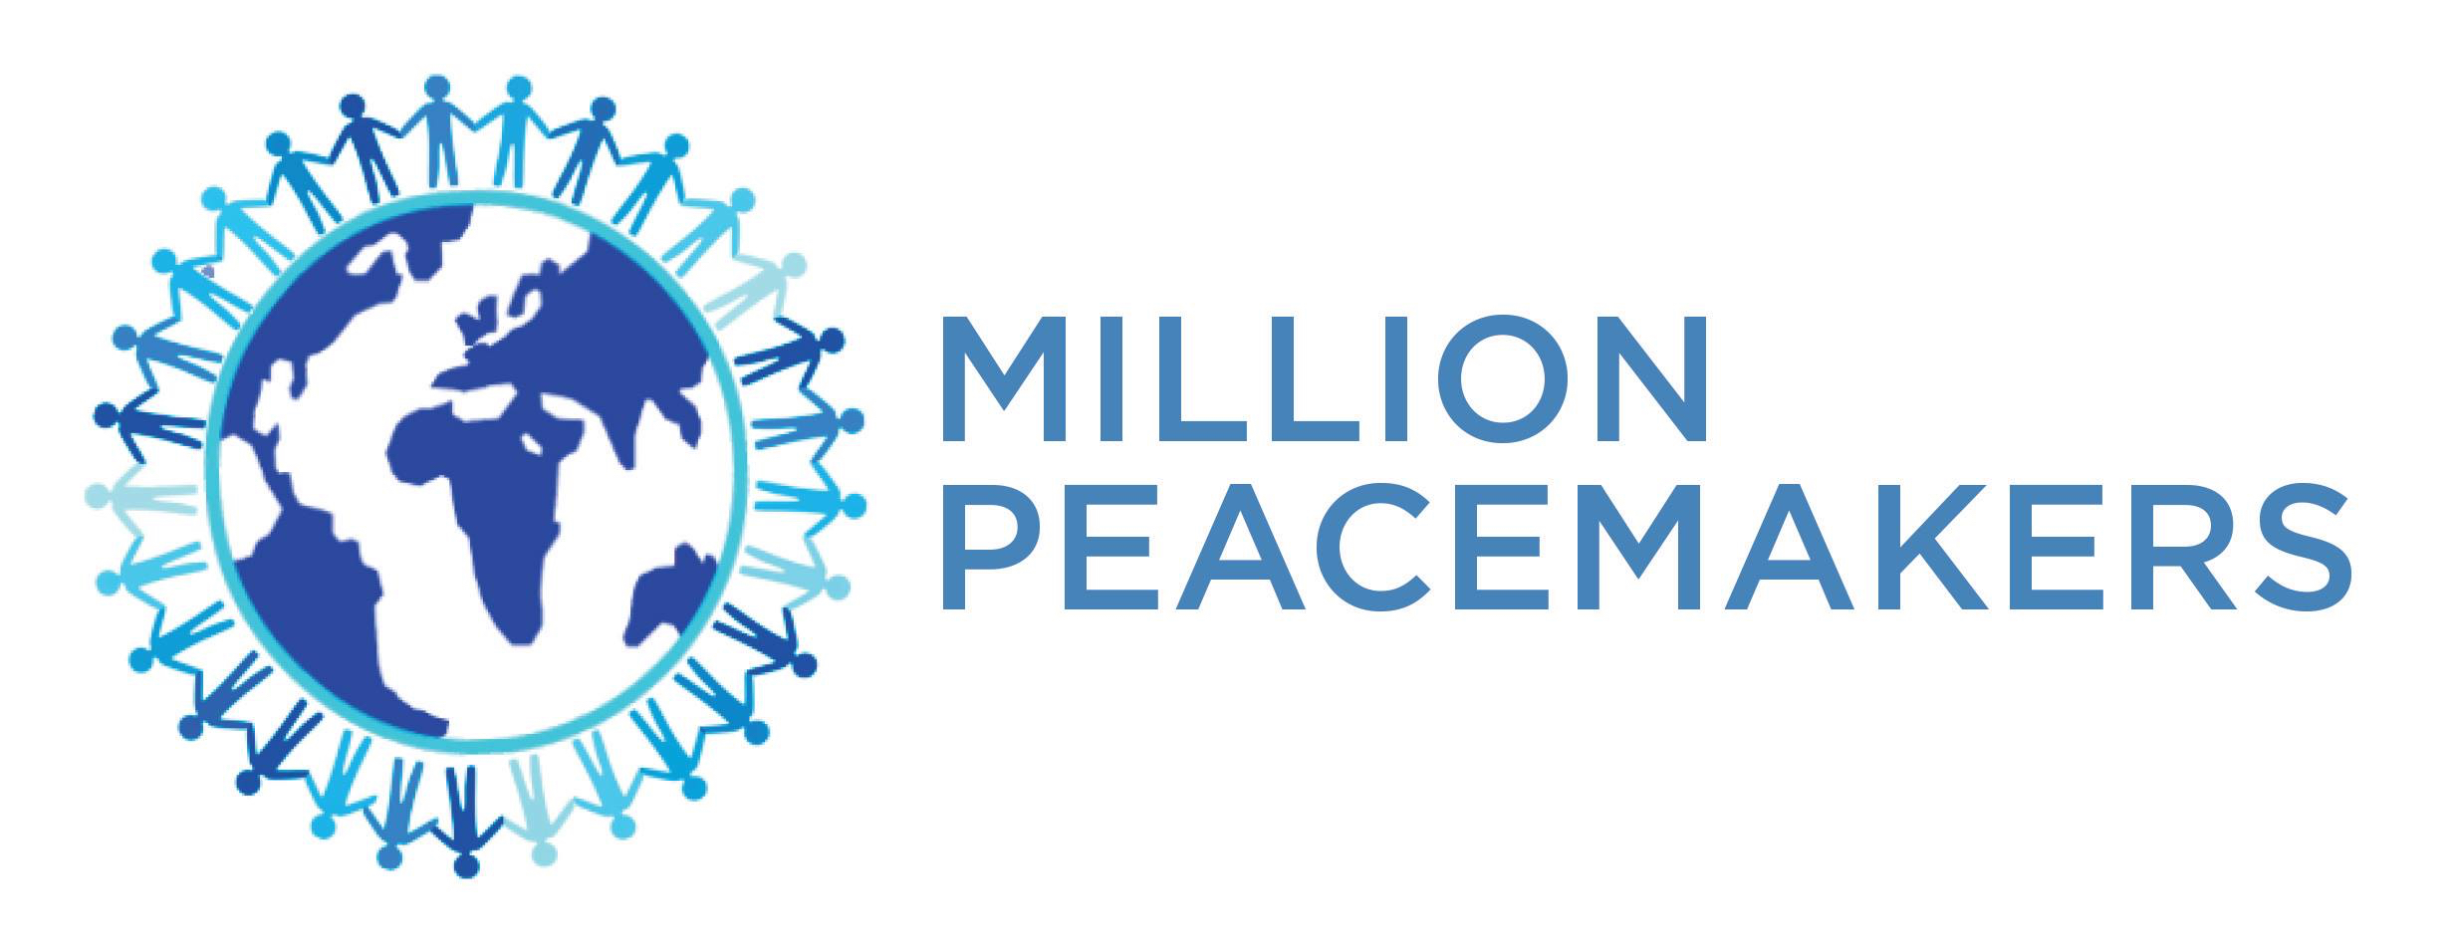

On-Site Workshop
NONFLICT
The Art of Every Day Peacemaking

NONFLICT - IMPACT ON BUSINESS

HUMAN ROI
An international study commissioned by CPP found that:
- 85% of employees deal with conflict at work
- 25% of employees admit to calling in sick or leaving early to avoid conflict at work
- Employees spend an average of 2.8 hours a week in conflict costing $359 Billion in lost productivity in the U.S. alone, which is 7% of your payroll.
- Unresolved conflict at home directly affects employee’s productivity at work.
The costs above do not include the money lost due to poor conflict resolution skills with external parties and relationships.
In today’s global marketplace, diversity in background and cultures, without inclusion, creates conflict due to differing work and communication styles.

NONFLICT CREATES:
- Trust between and with management and employees.
- Significant increase in “active listening”.
- Safe space to engage and eliminate negative behavior
- Freedom of clarity and straightforward conversations
- Empathy and respect (vs. tolerance)

On-Site Workshop
NONFLICT
The Art of Every Day Peacemaking

BENEFITS:
- Maximized effectiveness of discussions and contributions in meetings. Minimized politics, playing games (not video!).
- Deeper trusting relationships, knowing from where your colleagues ‘are coming’.
- Creative thinking producing new ideas, easier resolution of issues, forward and timely movement on opportunities.
- Zero tolerance on prejudice, negative attitudes and behavior, meaning pride in business and colleagues
- Inclusion of all, and the diverse perspectives, knowledge, experiences and opinions.

RETURN ON INVESTMENT:
- Happier humans. Research is clear - Community and Purpose are the critical variables to sustainable peace of mind and happiness.
- Reputation and brand earned as the preferred place to work.
- Positive momentum and impact on Talent Acquisition, Development and Performance, and Retention, especially of the “right fit”, sought after top talent.
- True inclusion of diversity of cultural backgrounds, mindsets and skillsets, gender, race, languages and experiences.
- Best cared for and experiences with clients and customers, vendors and suppliers, strategic partners, investors and all stakeholders. High ROV.

For further information: www.millionpeacemakers.org - www.ximenavéliz.com

