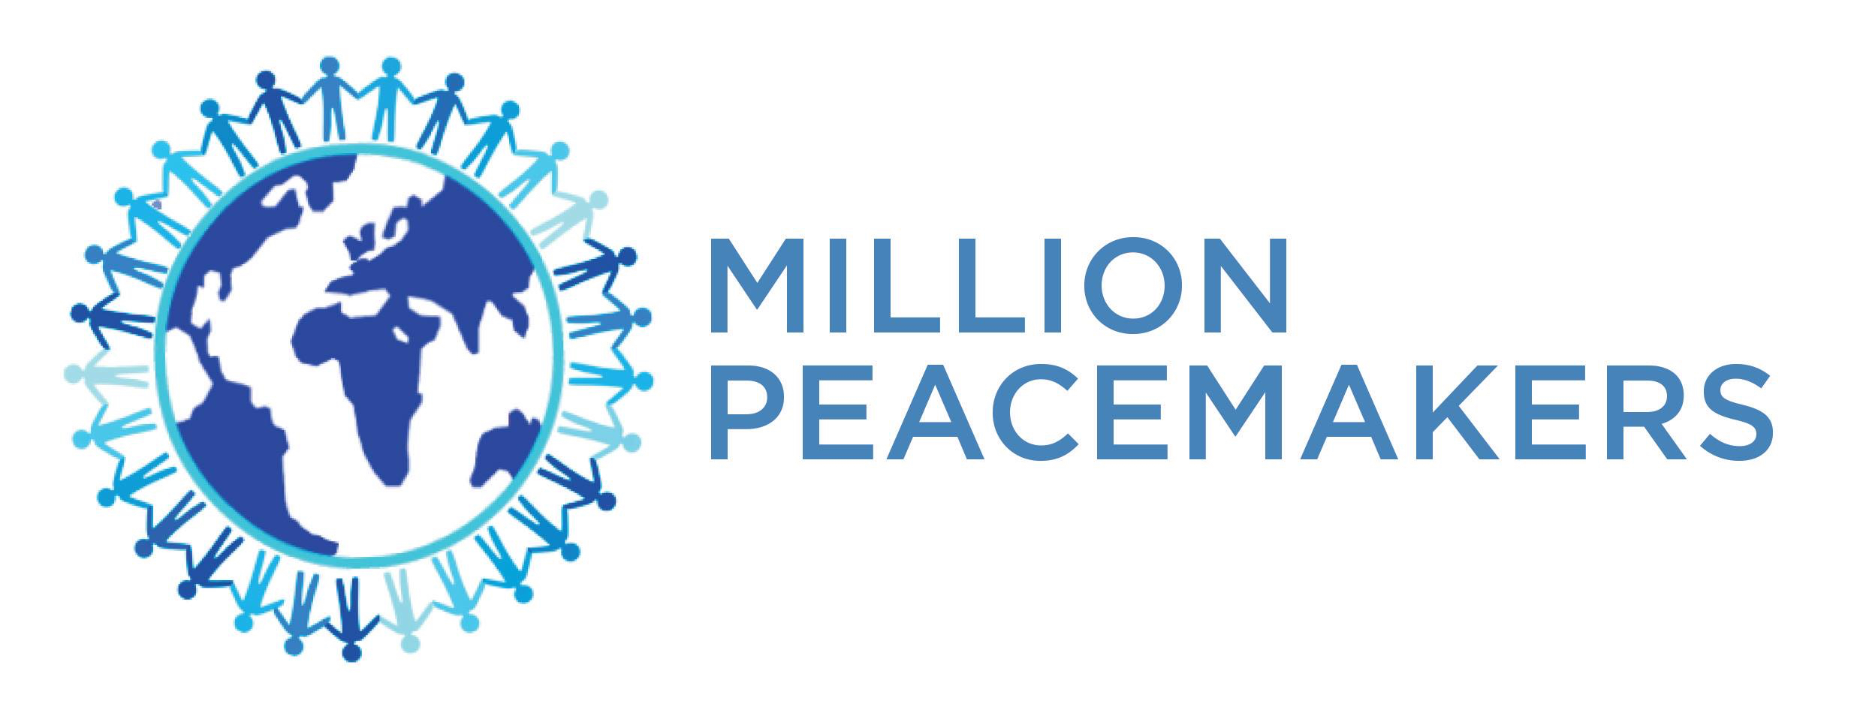

On-Site Workshop
NONFLICT
The Art of Every Day Peacemaking

A Foundation in Effective Conflict Resolution for Board Directors and Management teams

Conflict often happens in the boardroom between directors and among management teams. No one likes conflict, and most people will avoid it if they can.

Boards that recognize conflict and address it quickly have better governance. In fact, attrition rates on Boards that effectively address conflict is only 13%, compared with 24% on those that don’t.

A recent International Finance Corporation study found that 29.6 percent of contributors had experience with a boardroom dispute affecting the survival of an organization. In addition to the commercial cost of conflict, there is also a human cost. Recent studies have estimated that US employees spend three hours a week dealing with conflict, and if unresolved can result in the costly loss of valuable talent.

Providing Board Directors and Management teams with the skills to effectively resolve conflict demonstrates good corporate governance and lays the foundation for more efficient businesses.

What is Nonflict?

Nonflict is a unique and impactful method for resolving conflict developed by Stephen Hecht and Dr. Amir Kfir.

This simple and successful global program provides a structured approach to conflict resolution that encourages people in conflict to better understand themselves, one another and their differing perspectives.

It gives insight into and provides the skills to practice active listening and develop empathy among those who are in conflict. This in turn leads to greater trust between the warring parties, creating a safe space for reasoned discussion and laying the foundations for a resolution. Together they identify their ideal shared reality, taking active steps to co-create that reality, thereby resolving conflict at limited cost to both parties.

This process has been successful in helping organizations deal with issues of conflict and encourage better, wiser and more timely business decisions.

On-Site Workshop
NONFLICT
The Art of Every Day Peacemaking

Nonflict Workshop

Led by certified coaches, we facilitate an interactive workshop for your Board and Management teams to be trained in the Nonflict method of conflict resolution.

The workshop aims to:
- Provide participants with tools to transform conflict from destructive to constructive; leading to resolution, growth and better decision making.
- Encourage participants to better understand conflict resolution styles, both theirs and those of other people
- Teach attendees the Nonflict way and how it can be applied immediately to their real-life examples of current conflict
- Provide participants with a mentor program, whereby the coaches check-in regularly to ensure accountability of attendees in pursuing conflict resolution strategies

Following that, attendees have the option to work through an existing conflict with our certified coaches in an afternoon session.

Nonflict Check In
Once our coaches have taught the Nonflict method, we conduct a series of regular conflict resolution check ins, to ensure the commitments made in the workshop are being adhered to and further conflicts are being effectively managed.

These can be tailored to meet the needs of the respective parties, but can include:
- Check in with the warring parties
- Check in with the management that the conflict has been resolved and there are no further issues
- The timing of these depend on the needs of the management and executive team.

Nonflict Refresher
Our coaches conduct a condensed, refresher version of the workshop, focusing on the conflict resolution methods taught by Nonflict and resolving a real time conflict, typically these last 4 hours.

Onboarding
Include Nonflict as part of the company’s HR onboarding strategy

One on One Coaching
Introduction -
In addition, we provide ongoing one on one coaching sessions for executives, focused on
- Management techniques
- Life coaching
- Issues management
- Presentation training

On-Site Workshop
NONFLICT
The Art of Every Day Peacemaking

Testimonials from attendees:
I attended your recent seminar in Toronto and just want to say Thank You for the impact it had on me. First of all, I was able to use the tools taught in the seminar to deal with a vital meeting the following day I had with my employees and their union. Later, my wife and teenage daughter had an explosive argument and I used the Nonflict way to a peaceful resolution. We even all embraced with hugs in the end!”
Thanks again,
Jason Rosset, President, Accuworx Inc.,
"A few weeks ago I was present in the "Art of Peace" YPO program in Calgary. I need to let you know I have helped out my friends with a conflict in a partnership by lending the card and having them work through it. In 2 years, they have never spent more than 20 min together, their lunch was 3 hours together last week..."
John Fitzsimmons, Calgary
We at Danone Waters in Spain believe and drive for a very diverse workforce. At times, like any healthy vibrant business environment that embraces diversity, we have conflict. We have brought in the Nonflict in training our management with the goal of transforming diversity into an asset. We found it so effective we have decided to translate the book into Spanish and with permission of the authors we are now sharing Nonflict throughout our organization.
Christian Stammkoetter, Danone Waters, Spain- CEO
“I came away from the Nonflict training with a paradigm shift. I realized that I don’t have to be a victim in conflict; rather, I can be a participant in constructive resolution. Additionally, the workshop opened my eyes to everyone’s need for empathy and has led to me having deeper relationships at work, at home and in my community.”
Stanley Dumornay, President, Dumornay-Delis Inc., (Montreal)
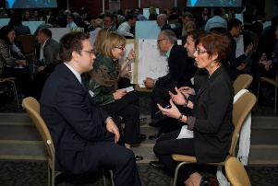
“On behalf of my Chapter, I would like to thank YPO International, the International Education Committee for coming, and for conducting a truly emotive and transformational workshop. The enthusiasm that you have all sparked is still resonating with our members.”
Nadeem Noordin, Education Chair, YPO Tanzania

On-Site Workshop
NONFLICT
The Art of Every Day Peacemaking

Nonflict Coaches are trained and certified directly by the co-founder of Nonflict and CEO of Million Peacemakers, Stephen Hecht. In order to achieve certification, every coach must have completed the training, which includes conducting a Nonflict coaching session.

Stephen Hecht is one of the founders of Million Peacemakers and co author of Nonflict, The Art of Everyday Peacemaking. He has extensive experience in conflict resolution, and as a leader in family businesses, as a spouse, sibling, father, and stepfather, Stephen has resolved many challenging conflicts. Winner of the Canada Award for Business Excellence, Stephen has led educational events internationally that have won YPO's Best of Best Award.

Ximena Véliz, Certified Nonflict Coach
English, Spanish, French
With more than eighteen years of global Intercultural Coaching experience, Ximena is the Co-owner of a Well-being and Personal Development Center in Geneva, Switzerland. She has previously worked at Geneva HQ’ed Multinationals, and Private Banking. Ximena leads workshops for corporate, family office and non-profit organizations, as well as for youth from elementary schools to universities, trades and specific skills training entities, and government.

For further information: www.millionpeacemakers.org - www.ximenavéliz.com

